**BONDING ASSIGNMENT**

Attached to the back of your work is a marking key. This explains how you achieved the mark shown on the front page. The marks are broken into four categories: N/A, Developing, Adequate and Excellent. To achieve a mark, you have to fulfil the criteria written in that box.

Included below are examples of what you should have included for full marks. For the first section (metals), I have shown the difference between what a ‘developing’, an ‘adequate’ and an ‘excellent’ response might look like. For the subsequent three types of materials (ionic, covalent molecular and covalent network) I have only shown the ‘excellent’ response.

**STRUCTURE OF METALS**

|  |
| --- |
| **DEVELOPING: (Misses some details when describing structure)**  Metal substances are when two metals join together. They have a ‘sea’ of delocalised electrons which flow through the metal lattice. |
| **ADEQUATE: (Describes the nature of metals AND the forces of attraction between particles)**  Metallic substances consist of multiple metal atoms bonded together. Metals are arranged as a lattice of positive metal ions surrounded by a ‘sea’ of delocalised electrons. These delocalised electrons can move freely throughout the metal, even in a solid state. The material is held together by electrostatic attraction between the positive ions and the negative delocalised electrons. |
| **EXCELLENT: (Same as ‘Adequate’ but also provides a useful diagram to show structure)**  Metallic substances consist of multiple metal atoms bonded together. Metals are arranged as a lattice of positive metal ions surrounded by a ‘sea’ of delocalised electrons. These delocalised electrons can move freely throughout the metal, even in a solid state. The material is held together by electrostatic attraction between the positive ions and the negative delocalised electrons. |

**PROPERTIES OF METALS**

|  |
| --- |
| **DEVELOPING: (States the properties of a metal without giving reasons)**  Metals are hard, have a high melting and boiling point, are malleable and conduct electricity. |
| **ADEQUATE: (States the properties of metals and gives general reasons)**  Metals are hard because of the electrostatic attraction between particles. This is also why they have a high melting point and boiling point. They are malleable because the ions can move over one another without breaking bonds. They can conduct electricity because of the delocalised electrons. |
| **EXCELLENT: (States the properties of metals and gives explicit reasons)**  Metals are hard because there is a strong electrostatic attraction between positive ions and negative delocalised electrons. This means it takes a great force to separate particles. Similarly, the strong attraction between particles gives metals a high melting point and boiling point, as large amounts of thermal energy is required to break the strong electrostatic bonds. Metals are malleable because the electrostatic attraction is ‘non-directional’, and if the ions are relocated due to force then they can form new bonds with nearby electrons. Finally, metals can conduct electricity because of the delocalised electrons, which can move through the metal material to carry an electrical charge. |

**USES OF METALS**

|  |
| --- |
| **DEVELOPING: (States a use of a metal)**  Copper is used in the home to make cooking pots and electrical wiring |
| **ADEQUATE: (Gives general reasons for the use of a metal)**  Copper is used to make cooking pots because it has a high melting point, and to make electrical wiring because it conducts electricity |
| **EXCELLENT: (Gives explicit reasons for the use of a metal)**  Copper is used in materials such as cooking pots and electrical wiring. The malleability and ductility of copper make it good for these purposes, allowing it to be shaped as desired (into pots or drawn into wires). Copper is a very good conductor of electricity, making it good for using in wiring. Copper’s use in cooking pots is due to its excellent thermal conductivity, which allows heat to be spread throughout the metal for efficient heating during cooking. Copper is also resistant to corrosion, which makes it more suitable for these roles than other metals such as iron. |

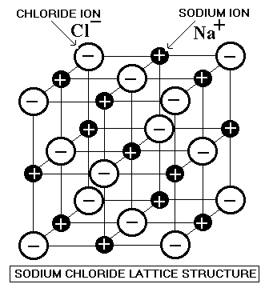**IONIC**

Ionic substances consist of positive and negative ions organised in a three-dimensional crystal lattice. The lattice is arranged so that positive ions (cations) are surrounded by negative ions (anions). The strong force of electrostatic attraction between the anions and the cations holds the material together.

The arrangement of ions and their attraction gives ionic substances a number of characteristic properties. Ionic substances are usually solids with high melting points, because large amounts of thermal energy are needed to break the strong electrostatic attraction between ions. Similarly, this is why ionic substances are hard. They are, however, brittle because a force applied can cause of a row of ions to ‘slip’, causing like-charges to become adjacent and repel, shattering the material. Ionic substances are unable to conduct electricity in the solid state because the charged particles (ions) are in fixed positions, however if the material melts or dissolves then the ions because free to move and carry charge.

One example of an ionic substance used in the home is sodium chloride (table salt). Sodium chloride is typically used as a flavour enhancer. This is because of sodium chloride’s flavour, ready availability, and non-toxicity. The brittle nature of sodium chloride means it can be broken into small grains for easy dispensing. Sodium chloride is soluble in water, which allows it to be added to cooking water to flavour foods because produced. Sodium chloride also has some non-food related uses. In areas where temperatures reach freezing point in winter, salt can be used to lower the freezing point of water due to its colligative properties, preventing ice from forming around the home.

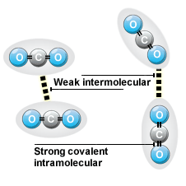**COVALENT MOLECULAR**

A covalent bond is formed when valence electrons are shared between two non-metals. This allows the non-metal atoms to achieve a stable ‘noble gas’ configuration. In covalent molecular substances, atoms are bonded together into individual (‘discrete’) molecules. The covalent bonds between atoms of the covalent molecule are very strong, but between different molecules there is only a weak intermolecular force.

The properties of covalent molecular substances are largely due to the weak intermolecular forces between different molecules. Covalent molecular substances have low melting and boiling points, and a number occur as gases or liquids at room temperature. This is because only a small amount of thermal energy is required to break apart the weak intermolecular forces holding molecules together. This is also why covalent molecules have odours; molecules can easily vaporise and enter the air, then becoming dispersed. The weak attraction between particles also means that covalent molecular substances are typically soft. Covalent molecular substances cannot conduct electricity as a solid or liquid because they have no charged mobile particles or delocalised electrons. Some covalent molecular substances do, however, conduct electricity when dissolved in water because they ionise e.g. HCl(g) 🡪 H+(aq) + Cl-(aq).

An example of a common covalent molecular substance found in the home is water (H2O). Water is required for survival, and is delivered in a purified form known as drinking water. Water also has a number of other uses, such as cooking and cleaning. The weak intermolecular forces holding water molecules together give it a low freezing point (0oC) , which makes it possible to freeze water as ice and use it to cool other objects (e.g. drinks). Water also has a relatively low boiling point of 100 oC, which means water can be heated to it’s boiling point to heat food for cooking. Water is a polar substance, which allows water to interact with and dissolve chemicals like soaps and detergents for the purposes of cleaning.

**COVALENT NETWORKS**

Covalent networks are large network lattices that have every atom joined by strong covalent bonds. These strong bonds extending throughout of the lattice hold all of the particles in place. Covalent networks are different to covalent molecular substances because there are no discrete molecules, and therefore no weak intermolecular forces holding particles together. In most covalent network substances the network of bonds extends in three dimensions, however one substance (graphite) has a two dimensional network, with different sheets joined by a layer of delocalised electrons.

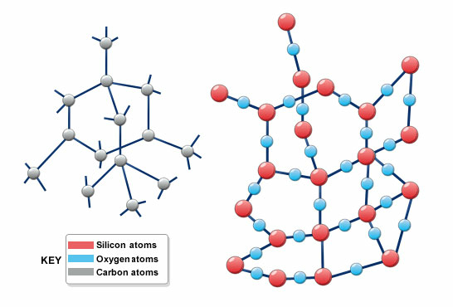

Carbon atoms

Covalent bonds

*Network of diamond*

Covalent networks have very different properties to covalent molecules due to the different arrangement of particles. All atoms are joined by strong covalent bonds and it would take a lot of thermal energy to separate particles, giving covalent networks a high melting and boiling point. Covalent networks are typically hard for a similar reason; it is difficult to break the strong covalent bonds. If a sufficient force is applied, however, the bonds will break and not reform, causing the crystal to shatter. Most covalent networks (with the exception of graphite) do not conduct electricity as a solid or liquid, because there are no charged particles which are able to move. Graphite is able to conduct electricity because of the delocalised electrons located between the layers of carbon atoms.

One example of a covalent material used in the home is diamond. One such use is in the form of jewellery. Diamonds are transparent, and when polished are able to reflect and refract light. Diamonds are chemically inert and do not oxidise in air at temperatures under 700 oC. They are also extremely hard which prevents them from being unintentionally scratched or damaged. Diamonds are also used in cutting and grinding tools such as drill bits and saws for their hardness. Cutting equipment can be tipped with small amounts of diamond to increase the hardness of the drill. Diamonds also have a very high melting point, which is important for withstanding the high temperatures resulting from friction during grinding.